**PROPOSAL PROJECT**

 **“ PHARMACY MANAGEMENT SYSTEM“**

**BY:**

**ABDULATI K.S JAHBEL - 1841720223**

**TROY NUGROHO MUKTI - 1841720069**



**STUDY PROGRAM INFORMATICS ENGINEERING**

**DEPARTMENT INFORMATION TECHNOLOGY**

**STATE POLYTECHNIC OF MALANG**

**2021**

|  |  |  |
| --- | --- | --- |
| logo_hitam_thok copy | KEMENTERIAN PENDIDIKAN DAN KEBUDAYAAN  **POLITEKNIK NEGERI MALANG**  **JURUSAN TEKNOLOGI INFORMASI**  **PROGRAM STUDI TEKNIK INFORMATIKA**  Jl. Soekarno Hatta No.9 Malang 65141  Telp (0341) 404424 – 404425 Fax (0341) 404420  Laman://www.polinema.ac.id Email:cs@polinema.ac.id | LOGO ISO BERWARNA |

27 September 2021

Number : 001/ECT/I/2021

Attachment : -

About : Application Offer Letter

Dear. Head of Study Program DIV Informatics Engineering

Pharmacy shop management system project is a computer-based software developed for managing, monitoring, and recording numerous activities of medical stores. It plays a key role in raising the productivity of medical stores through machine-controlled functions.

Through this offer letter, we offer a computer-based software proposal for the company/institution that you are leading. The software design proposals that we offer have been attached together with this letter.

Thank you for your attention and cooperation.Thus we make this offer letter, Thank you for your attention.

Regards,

Malang,27 September 2021

Project Team 6

**DAFTAR ISI**

[**CHAPTER 1 PRELIMINARY** 4](#_Toc84246852)

[**1.1 Background** 4](#_Toc84246853)

[**1.2 Purpose** 5](#_Toc84246854)

[**1.3 Benefit** 5](#_Toc84246855)

[**1.4 Project Scope / System Offered** 5](#_Toc84246856)

[**1.5 Staffing** 5](#_Toc84246857)

[**CHAPTER 2 Budget** 7](#_Toc84246858)

[**2.1 Business Model** 7](#_Toc84246859)

[**2.2 Budgeting** 7](#_Toc84246860)

[**DAFTAR PUSTAKA** 8](#_Toc84246861)

# **CHAPTER 1 PRELIMINARY**

## **Background**

Pharmacies are involved and are responsible for wide area activities in industries. Pharmacies are involved in drug discovery, drug safety, marketing and management of drugs. They need to ensure the right use of medicines.

Pharmacists are really busy people, they need to store the drugs, do calculations on prices, and also manage the inventory of the drugs. That is why non nondigital way or manual is very slow and non-optimal to conduct the role of pharmacist. That is the reason we want to create our system to help the

pharmacy thrives in their activities.

Irwansyah (2012) in a journal entitled “Rancang Bangun Sistem Informasi Manajemen Apotek Berbasis Client Server (Studi Kasus: Apotek Bakita Kubu Raya)”, stated that pharmacies are used to provide drug products and services. The management of the pharmacist's duties is planning, implementing, monitoring and evaluating the pharmacy. In pharmacies or medical stores, there are activities for determining prices, inputting purchase and sales data, and recapitulating reports on all activities.

Pharmacy shop management system project is a computer-based software developed for managing, monitoring, and recording numerous activities of medical stores. It plays a key role in raising the productivity of medical stores through machine-controlled functions. It conjointly helps to beat manual pharmacy management problems and can play a key role in minimizing human strain and errors once it involves pharmacy management.

## **Purpose**

Project scope defines the boundaries of a project. Think of the scope as an imaginary box that will enclose all the project elements/activities. It not only defines what you are doing (what goes into the box), but it sets limits for what will not be done as part of the project (what doesn’t fit in the box). Scope answers questions including what will be done, what won’t be done, and what the result will look like.

## **Benefit**

It plays a key role in raising the productivity of medical stores through machine-controlled functions. It conjointly helps to beat manual pharmacy management problems and can play a key role in minimizing human strain and errors once it involves pharmacy management

## **Project Scope / System Offered**

#### Pharmacy Shop Management System Main features :

* Manage record of all medicines
* Manage the number of sold medicines
* Manage the number of purchased medicines
* Manage record of stock information
* Manage record of product information
* Manage record of Stock quality information
* Notify the user for expired product

## **Staffing**

|  |  |  |
| --- | --- | --- |
| **Lead Engineer** | | |
|  | Nama | Troy Nugroho Mukti |
| NIM | 1841720069 |
| Alamat | Dsn. Sumberkembar Kec. Pacet Kab. Mojokerto |
| Telepon | +6285815539743 |
| Email | nugrohotroy77@gmail.com |
| **Engineer** | | |
|  | Nama | Abdulati K.S Jahbel |
| NIM | 1841720223 |
| Alamat |  |
| Telepon |  |
| Email |  |

### 

# **CHAPTER 2 Budget**

## **2.1 Business Model**

There are 3 User for This System :

|  |  |  |
| --- | --- | --- |
| No | User | Function |
| 1 | Administrator | Check Drugs Stock |
| Input Drugs Data |
| Update Drugs Data |
| Login |
| Check Drugs Data |
| Notify the Expired Product |
| Check Sales Report |
| 2 | Stock Manager | Check Drugs Stock |
| Update Drugs Data |
| Login |
| Check Drugs Data |
| 3 | Manager | Login |
| Check Drugs Data |
| Check Sales Report |

Use Case Diagram

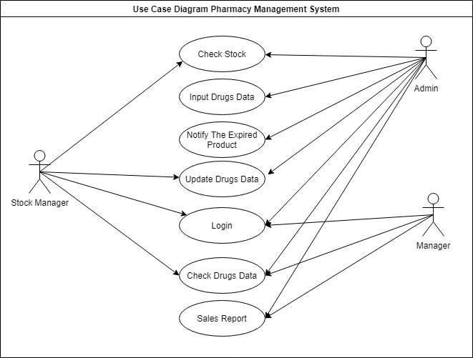

## **2.2 Budgeting**

### 

|  |  |  |  |
| --- | --- | --- | --- |
| **No** | **Task Name** | **Duration** | **Cost** |
| **1** | Project preparation and planning | 4 Days | Rp.2.000.000 |
| **2** | Process Analysis | 11 Days | Rp.6.000.000 |
| **3** | Design and Implementation Process | 18 Days | Rp.10.800.000 |
| **4** | Hosting Server and Maintenance | 20 Days | Rp.11.700.000 |

# **DAFTAR PUSTAKA**

Irwansyah, M. A. (2012). Rancang Bangun Sistem Informasi Manajemen Apotek Berbasis Client Server (Studi Kasus: Apotek Bakita Kubu Raya). *Jurnal ELKHA*, Vol 4 No 2, Oktober 2012.